**Rest Enhance Step Document**

**Objective:**

Append the appup Request info to rest step.

**Concepts:**

1.Using OkHttp to process the REST call.

**Rest Enhance Step Json:**

{

"workflows": [

{

"name": "rest-step",

"id": 200,

"trigger": "rest",

"expression": "rest",

"method": "GET",

"steps": [

{

"type": "start",

"id": 1,

"next": {

"start": "start"

}

},

{

"url": "https://searchoracle.techtarget.com/definition/stored-procedure",

"method": "get",

"headers": [

{

"key": "header1",

"value": "hvalue1"

},

{

"key": "header2",

"value": "hvalue2"

}

],

"output_variable": "restOutput",

"raw": "",

"value_type": "hb",

"query_parameters": [

{

"key": "name",

"value": "rajnish"

},

{

"key": "address",

"value": "hyderabad"

}

],

"body_parameters": [

{

"key": "restBody",

"value": "bodyValue"

},

{

"key": "restBody2",

"value": "bodyValue2"

}

],

"auth_type": "basics",

"username": "",

"include_request_info": "true",

"password": "",

"consumer_key": "",

"consumer_secret": "",

"token": "",

"secret": "",

"type": "rest-enhance",

"id": "start",

"next": {

"success": "hangup",

"failure": "hangup"

}

}

]

}

],

"filters": [],

"server": {},

"plugins": []

}

**Rest Enhance Step Attributes Description:**

|  |  |
| --- | --- |
| **Attributes** | **Description** |
| **1.url** | Provide rest url. |
| **2.method** | Provide type Request method. |
| **3.headers** | Header List contains the list of Request Header keys and values. |
| **4.output_variable** | Used to store the response of the request. |
| **5.raw** | Provide raw data for GET type request method. |
| **6.value_type** | Value_type used to set the value type.  Value types are two types.  1.hb-HandleBars  2.ftl-Freemarker Template Language. |
| **7.query_parameters** | Query_parameters list contains the list of query parameters for request. |
| **8.body_parameters** | Body_parameters list contains the list of body parameters for request. |
| **9.auth_type** | Provides the type of auth.  1.basic  2.oauth1.0 |
| **10.include_request_info** | Provide boolean value. |
| **11.username** | Used for basic Oauth authentication. |
| **12.password** | Used for basic Oauth authentication. |
| **13.consumer_key** | Provide consumer_key |
| **14.consumer_secret** | Provide consumer_secret |
| **15.token** | Provide token |
| **16.secret** | Provide secret |

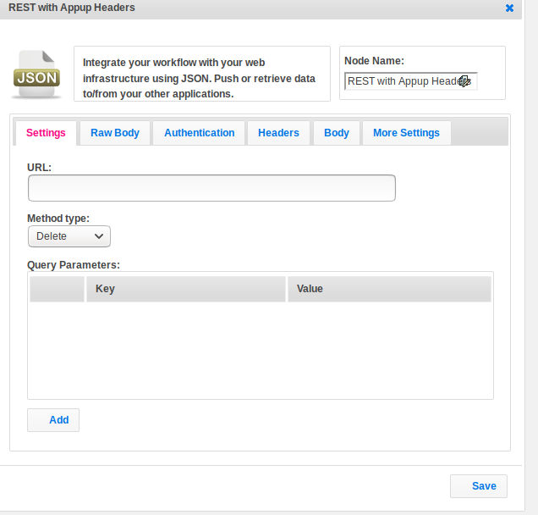

**Rest Step Execution Flow:**

**Logic:**

Get the all information provided by appup and add this info(header,quary_params and body) to rest call,which is written in your rest step.